Elmira District Secondary School

SPH3U
Course Notes
2012

Student Name:

Introduction and Group Work

 | Lesson | Topics | Materials | Homework
1 | Welcome to Physics & Course Introduction | Scientific Notation, Significant Digits |  | Read: course handouts.  Log on to course website.  Sig Dig HO  Read: pg. 566, “Significant Digits”  Read: pg. 565, “Scientific Notation”  Video: The Known Universe  Lesson: Scientific Notation
2 |  | Graphing, Conversion Factors |  | Review Your Understanding HO
3 | Work period
4 | Group Work |  |  | Read in Handbook: Group Work
5 | Measurement  How to Answer a Question |  |  | Video: The Big Bang

Day 6 - Quiz on Scientific Notation, Significant Digits, Conversion Factors

Significant Digits SPH 3UI – Day 1

Every scientific measurement is associated with some degree of uncertainty. For example, a pencil was found to be 213.5 mm long. If the ruler used to measure this is marked in millimeters, the .5 represents a point between twon lines on the ruler and is therefore only an estimate. We are really estimating that the pencil is 213.5 mm long. It could really be anywhere from 213.3 mm to 213.7 mm. We can’t tell for sure because the instrument we are using to measure it only gives us accuracy to the nearest millimeter. The pencil is definitely 213. mm long (we can read that much on the instrument) and maybe up to 213.7 mm long. The 213 is known for sure (certain) and the .5 in not known for sure (uncertain). Significant digits are those digits that are certain plus one uncertain digit. 231.5 has 4 significant digits made of three certain digits and one uncertain digit.

Significant digits carry meaning. Reporting more digits than are significant is implying more knowledge than you have and thus a lie.

Rules for Determining the Number of Significant Digits:

1. All digits 1-9 are significant. If they are written they must be true and meaningful. The only digit that causes problems is 0. When is 0 a meaningful number (significant) and when is 0 just a place holder (insignificant)

ex. 12.57 4 SD 134.567 6 SD 7 1 SD

2. All 0’s between two significant digits are significant. They represent the number 0 not just a place holder 0.

ex. 101.903 6 SD 100.2 4 SD 2011 4 SD

3. Any 0 printed to the right of a non-zero digit is significant unless it/they are used merely as place holders. Usually a decimal is used to indicate significance.

ex. 500. 3 SD 500 1 SD

4. Any 0’s to the left of significant digits serving only to locate the decimal place are not significant.

ex. 0.0005 1 SD 0.00053 2 SD
0.00050 2 SD 1.0050 5 SD

Operations and Calculations Involving Significant Digits

1. Addition & Subtraction
Place bars on uncertain digits. Carry the bars through the calculation. Report all unbarred (certain) plus one barred (uncertain) digit.

ex. 64.08

- 4.17

+6.1

66.01 66.0 66.0

2. Multiplying & Dividing

The answer must have the same number of significant digits as the value with the least number of significant digits in the question.

ex. 16.4 * 3.8 = 62.32 62

ex. 10 / 3.1 = 3.225806452 3

3. Infinite significance

Numbers with infinite significance do not affect the number of significant digits. (ex. dozen, 2 groups, 3 times as big – ask yourself, was the number a measurement which has uncertainty ( 3 cm ) or a given number that has infinite certainty ( 3 piles ). When you count a dozen of something there is no estimating involved. Either you have a dozen or you don’t.

ex. 101 divided into 3 piles = 33.66666666666666666666 33.7

4. Multiple Operations
Remember order of operations – BEDMAS ! When performing multiple operations carry extra significant digits while doing the calculation but keep track of how many significant digits there should be. Report the final answer with the proper number of significant digits.

ex. 15.5 * 3.1 + 1.2 or 15.5 *3.1 + 1.2
3 SD 2 SD = 48 48.05
+ 1. 2 +1.2
49. 2 49 49.25 49.2
Excercises

1. How many significant digits? Re-write each example in proper scientific notation.

a) 197 b) 0.6178 c) 0.61780

d) 6.080 e) 0.050 f) 20.

g) 5.0320 h) 0.000200 i) 70.70

j) 25.00 k) 600 l) 789832

2. Perform the following calculations and express your answer with the correct number of significant digits and in scientific notation.

a) 0.21 + 4.33 + 0.008 b) 134.8 + 2.05 - 13

c) 14.896 - 2.42 + 4.60 d) 0.50/4.12

e) 4.18 * 0.051960 f) 2 * 6.3 – 0.001

g) (17.04 - 3.135) / 0.25 * (5.0 + 1.10)

h) (20.01 * 1.021) / 0.0510 j) 120.90g / 12 eggs

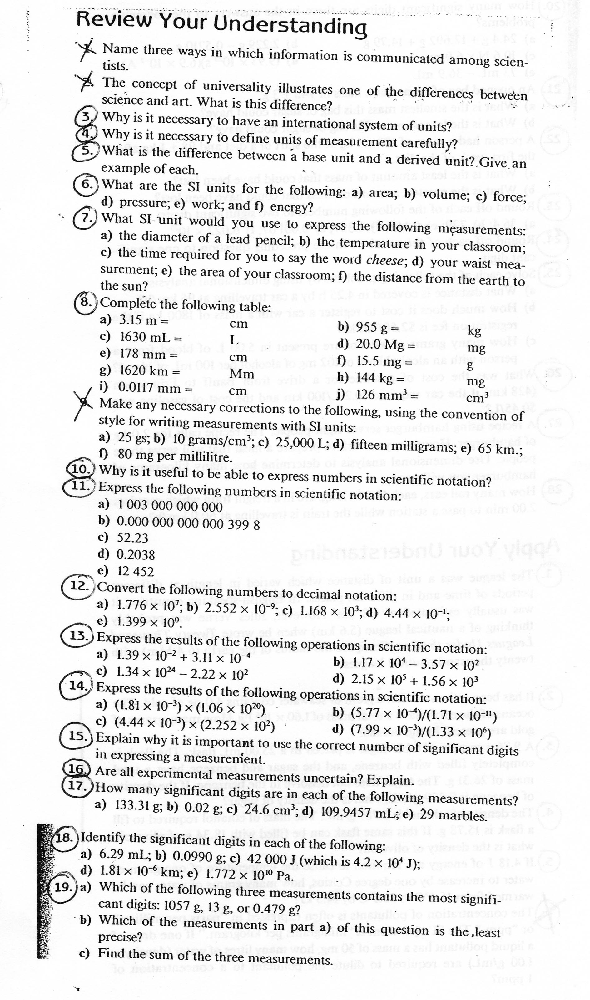
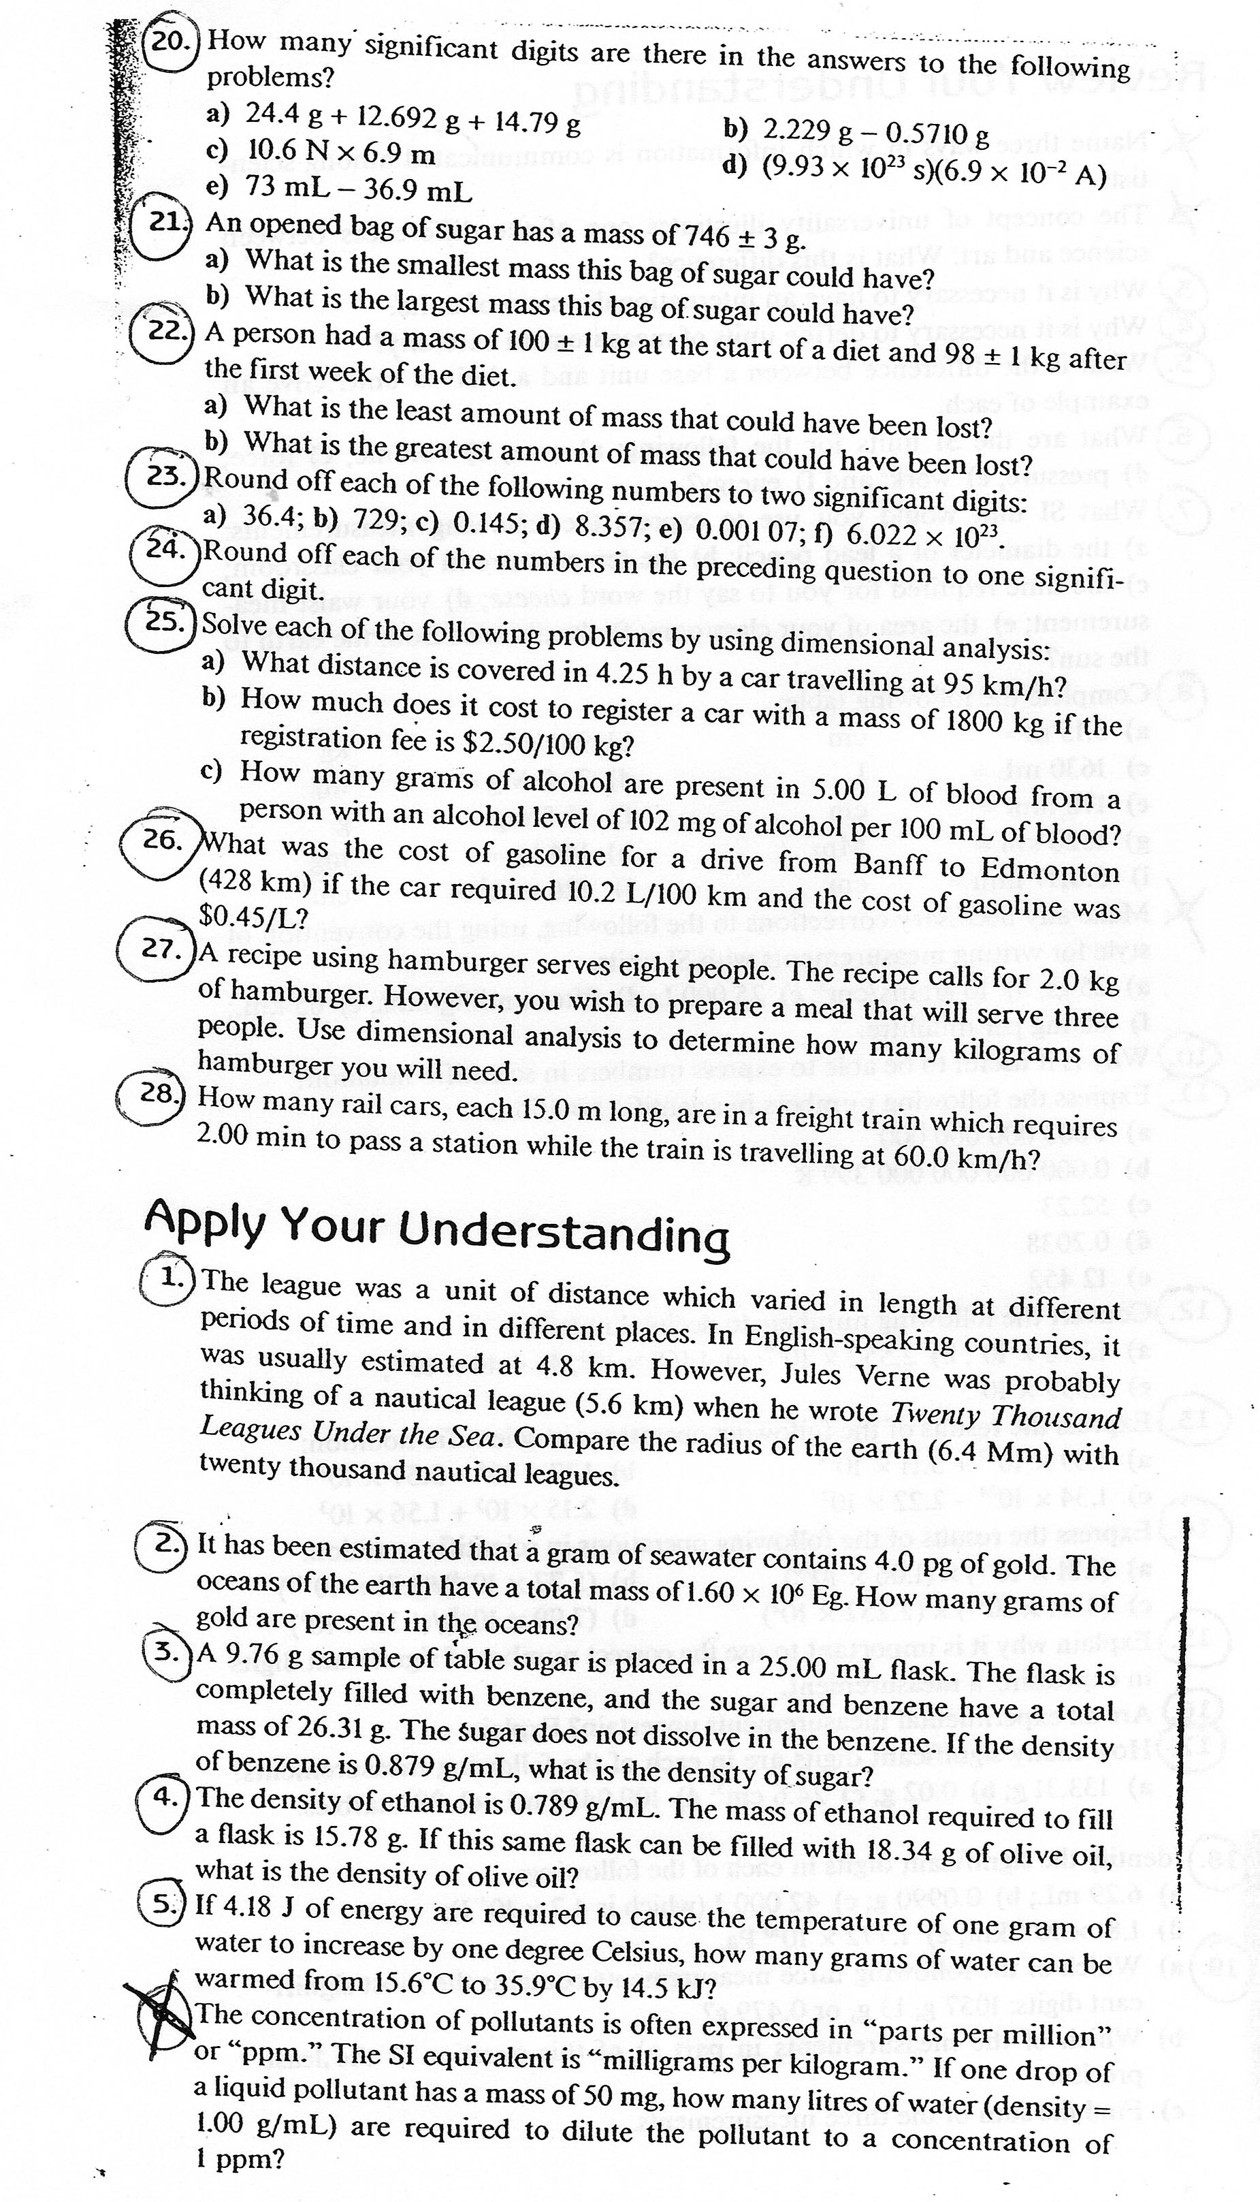
SPH 3UI - Day 2 & 3

SPH3U: How Groups Work – Day 4
Recorder: __________________
Manager: __________________
Speaker: __________________
0 1 2 3 4 5

Each group needs a whiteboard, marker and cloth. Assign each group member one role: Manager, Recorder, or Speaker. If there are four people in a group, two will act as the speaker. Working well in a group is a bit like acting in a play, we all have roles to perform!

A)
Manager: Ask the group members to read the following instructions for this activity.

The majority of our work in Gr. 11 physics will take place in groups. Take a few moments to think about our experiences of working in groups. Think about your experiences in other courses and your experience so far in Gr. 11 physics. We will discuss these experiences, but please don’t mention anyone’s name!

Manager: Ask the group to complete the next two questions individually, without any discussion. When you see that everyone has finished, have the group move on.

Complete the following two questions individually.

- In your experience, what are some of the enjoyable characteristics of working in groups?

- In your experience, what are some of the less-enjoyable characteristics of working in groups?

Work together now. On your whiteboard compile a list of the group’s responses to each question following the suggestions below.

Manager: Organize the discussion and ask for ideas from each group member.
Recorder: Neatly summarize the ideas on the whiteboard, write large enough so other groups could read it if you were to hold it up.
Speaker: Be prepared to speak to the class about your points when your group is called upon – if any points are unclear, ask your group questions.

Class Discussion

Continue the following questions as a group.
B)
Manager: Read out the next question (#3)and ask the group for their ideas. Kindly ask everyone for their input.
Recorder: Make sure what you write down on your own sheet accurately represents the group’s ideas – your teacher will be checking your copy. Ask the other members for clarification if you’re not sure you have it right.
Speaker: Be prepared to speak on behalf of the group. If any ideas are not clear, ask the others for an explanation or ask specific questions. Make sure the group explanations would receive a mark of “5” – are they thorough and complete?

- We have all experienced difficulties working in groups. Sometimes, the challenge comes from within – for whatever reason you, as an individual, are unable to contribute effectively to the group. Other times, another group member may make the proper functioning of the group difficult. Think about the reasons why a group might not function at its best. Make a list of the reasons in the chart below – be specific. However, do not mention the names of any individuals.
This is not a critique of your current group or any others you have been in.

Question 3 - Summary  Reason Groups Might Not Work Well | Question 4 – Summary  Actions
1.
2.
3.
4.

- Describe what specific actions could be taken to help the group work better in each case you listed above. Indicate which group member (R, M, S) would be best to carry out the action, or if it is an action for everyone (E).

Manager: When the group decides it had finished question 4, call the teacher over. Keep an eye on the clock since we want to complete the whole activity in this period.
Recorder: Write up one example on the whiteboard for a class discussion. Have the others check this.
Speaker: Be prepared to speak on behalf of your group when called upon. Make sure the action is clear and precise.

Class Discussion

Manager: Lead the group through the next question.

- Begin by working individually on the next question. In the chart below, list the responsibilities of your role in the group. When everyone is complete, share and discuss the results. Finally, complete the rest of the chart.

Manager | Recorder | Speaker
SPH4U: Group Work – Day 4 homework

The Idea
Group work is the main teaching format of the Gr. 11 physics course. Think of your group as your learning team - the people who will help you learn physics. Group membership will change every major unit, depending on the flow of the units in the course, and will always have a heterogeneous composition of students (all ability levels). Every student is expected to take-up a specific role within the group and to carry out the responsibilities listed below. Members of every group will evaluate one another on their performance in their respective roles. Roles within a group must change for each new task or activity.

Group Roles
Actions | What it sounds like
Manager  - Make sure everyone has read the initial instructions before starting.  - Direct the sequence of steps.  - Keep your group "on-track."  - Make sure everyone in your group participates.  - Watch the time spent on each step. | “Has everyone had a chance to read this before we continue?”  "Let's come back to this later if we have time."  "We need to move on to the next step."  "Ralph, what do you think about this idea?"
Recorder  - Act as a scribe for your group.  - Check for understanding of all members.  - Make sure all members of your group agree on the explanations in the group write-up  - Make sure names are on group products. | "Do we all understand this diagram?"  "Explain why you think that."  "Are we in agreement on this?"
Speaker  - Speak on behalf of your group when called upon in class discussions  - Ensure group ideas and responses are carefully explained.  - Check - Would the group explanations receive a mark of “5”? | "What other possibilities are there?"  "Let's try to look at this another way."  "Let’s try to flesh this out."  “I’m having trouble understanding this. Can we try another way to explain it?”

Table
human
human
human
Seating
When working in groups, please sit at the tables as illustrated to the right. This helps ensure that all members are able to interact easily with one another. When sitting three in one row, usually one person at the side is left out. I will constantly harass you to do this.

Whiteboards
One of the best ways to share work and ideas is using a whiteboard and your group's common workspace. This is much easier than all huddling around one sheet of paper. Please use these regularly!

SPH3U: The Art of Measurement – Day 5
Recorder: __________________
Manager: __________________
Speaker: __________________
0 1 2 3 4 5

Measurements are the backbone of all science. Any scientific ideas, no matter how slick, are only as good as the measurements that have confirmed them. Without careful measurements, science is mostly guess work and hunches – suspicions and rumours.

- The Meter Stick
The most basic scientific tool is the meter stick. But, do you know how to use it? For this investigation you will need one meter stick

- Examine the markings on the meter stick. What is the size of the smallest interval marked on it?

- Three students use the meter stick to measure the height of a desk and each reports their results: 95 cm, 94.8 cm, and 95.03 cm respectively. Considering the intervals marked on the meter stick, which result illustrates the best use of this measuring device? Explain.

The term significant figures describes which digits in a number or measurement are physically meaningful or reliable.

- How many significant figures are in the measurement you chose in question A#2?

- Measure the height of your desk and record the measurement with an appropriate number of significant figures.

- Two students each measure the length of a running shoe. One student records a result of “285”. The other student measures the same shoe and records the result “27.9”. How can two measurements of the same thing be so different … or are they? Explain by describing what critical element is missing from each measurement.

- Two students make a measurement using the metre stick. One student measures the thickness of a text book to be 5.1 cm (biology!) The other student measures the length of a pencil to be 18.4 cm. Which measurement is more precise? Offer an explanation and mention what you think the word precision means.

- The Stopwatch – Day 5 continued
Now we will examine another common measuring device. You will need one stop watch

A student drops a pencil from a height of 1.00 m. Another student times the fall. The stopwatch readout looks like this after the timing:

0:00.45

- Write this reading as a number in standard notation with units of seconds (s).

- What is the precision of the stopwatch according to its display (i.e. to the nearest …)?

- Perform the measurement four times, record the times below and calculate an average time.

Avg:

- How many significant figures are reasonable to use when writing down the calculated average? Explain.

In traditional notation, there can be some ambiguity about the number of significant figures a measurement has. Use scientific notation for clarity (clearly specifying the number of significant figures) or for convenience (very large or small numbers). Never write down all the digits your calculator computes – they are not always significant!

- The whole class times how long it takes one student to run from the class, down to the Cafeteria and back, simply by observing the classroom clock. The computed average of the class measurements is 78.6176548 s. Explain how to write this calculator result in an appropriate way.

SPH3U: How to Answer a Question? – Day 5 continued
Recorder: __________________
Manager: __________________
Speaker: __________________
0 1 2 3 4 5

The major focus of Gr. 11 physics is the careful explanation of our observations and ideas. Every word question you encounter should be carefully explained using complete sentences and correct English. Even if the question doesn’t actually say “explain”, you must still justify your answers and outline your reasoning. Below is a sample question from the Art of Measurement activity.

Two students make a measurement using the metre stick. One student measures the thickness of a text book to be 5.1 cm (biology!) The other student measures the length of a pencil to be 18.4 cm. Which measurement is more precise? Offer an explanation and mention what you think the word precision means.

Mark the student responses shown below using the following criteria:
a) Does it clearly answer the question asked? b) Is it complete?
c) Is the physics correct? d) Is it grammatically correct?

Use this marking scheme to determine the mark out of five:
- Work that is completely missing.
  - Work that is seriously deficient, incomplete, or lacking in fundamental understanding.
- Work that shows basic comprehension but requires improvement.
- Work which meets the expectations. The question is correctly and clearly answered.
- Exceptional work which demonstrates a thorough understanding and examination of the topic. The question is thoroughly and thoughtfully answered.

Response 1
The second measurement is more precise. It has three significant figures but the first one only has two. Precision is the number of significant figures, so the more significant figures a measurement has, the more precise it is.

0 1 2 3 4 5 because _________________________________________________________________

Response 2
The measurements are equally precise since they are both accurate to one millimeter, which is the smallest unit indicated on the metre stick.

0 1 2 3 4 5 because _________________________________________________________________

Response 3
Precision means how careful the measurement is done and there were no mistakes. Both measurements were careful to the one millimeter so they are equally good.

0 1 2 3 4 5 because _________________________________________________________________

Response 4
Precision describes the smallest unit of measurement or interval that the measurement device can distinguish. Both objects were measured in the same way with the same device and must have the same precision, which in this case happens to be to the nearest millimeter. The number of significant figures of the measurements (two and three) is not the same things as precision.

0 1 2 3 4 5 because _________________________________________________________________

