Elec 1

Time | Sources of electricity kit – solar, piezo, generator, battery, thermo, wet cell, potato clock
15 | Take up - Test Chemistry
30 | Notes - sources
30 | Video with handout– Nature of Things – Renewable Energy – still as VHS  Take up handout

Sources of Electrical Energy

What are 5 ways of making electricity? They probably only know three and will just
keep repeating the same one (generator)

demo each

1. Generator – any energy source (nuclear, wind, coal, oil, natural gas, Johnny from the generator demo the day before) used to turn a set of wires in a magnet. Shock the kids!

2. Chemical – batteries (wet and dry), fuel cell
wet cell – two metals immersed in a liquid electrolyte. Each metal has a different pull on e- and the electrolyte completes this circuit internally – messy – imagine powering your ipod with this

dry cell – same as wet cell but the electrolyte is a paste – not messy but needs to be recycled.

Fuel cell – fuel (H) must continually be added but the cell doesn’t get used up

demo wet cell and dry cell

3. Solar photovoltaic – uses light energy to move e-

4. Thermocouple – two metals connected - each has different hold on electrons - add heat and electrons will move from weak hold to strong hold
eg] meat thermometer

5. Piezo-electric crystal – a crystal that releases e- under pressure
eg] BBQ lighter

Almost all of our electricity comes from generators. These generators are powered by different fuels and these fuels can be classified as renewable or non-renewable.

Renewable energy source – can be restored within one human lifetime
Non-renewable energy source – cannot be replaced within one human lifetime.

Renewable | Non-renewable
Wind | Fossil fuels – coal, oil, natural gas
Water (hydro) | uranium
Solar
Tidal
Geothermal
Biomass

Electricity - Day 2

Time | Tesla coil, balloon, static electricity cart
40 | Note:  Unit 2 – Physics - Electricity  Examples of electricity: lightning, battery, static cling, power outlet  Static Electricity – a build up of charge on an object. This charge is not  moving (static)  If enough charge is built up, or if a pathway is provided for the  electrons, the charge may discharge – rapidly move from one place to  another.  Eg] drag feet across floor (build up charge)  touch friend’s ear (pathway to ground) – discharge  Lightning is just a large discharge of static electricity from cloud to ground (or ground to cloud) . The static buildup comes from ice crystals rubbing as the updraft (low pressure) pulls air and moisture up.  Demo – balloon rubbed on hair and stuck to wall  Demo – tesla coil – portable lightning?  Insulators – do not allow charge to move  Eg] plastic, glass, rubber  Conductors – allow charge to move  Eg] metals, saltwater  Law of Electrostatic Charges  1. Like charges repel  2. Opposite charges attract.  3. Charge objects attract neutral. – Why? The charged objects repels  like charges yet attracts the opposite charges in an object. The  opposite charges just end up closer so the pull is stronger than the  push  attract  + +  + +  + + -  -  + + -  -  -  -  -  -  -  -  -  -  -  -  -  -  -  -  -  -  -  -  repel  Transferring Charge – atomic theory helps to explain why objects become charged when rubbed. Review parts of an atom – P, N, e – which can move? Only e. The electrons are held loosely by an atom – think chemical energy vs. nuclear energy – so when a material is rubbed only the electrons are transferred. To get a negative charge the object gains electrons. To get a positive charge the object loses electrons. Atoms of different substance have different strength pull on electrons – electron affinity  See handout – Predicting Transfer of Electrons
15 | Predicting transfer of electrons handout
5 | Take up - Predicting transfer of electrons handout
HW | R+MN 388-393, 10.1  pg 398 # 1-5  pg 401 # 1-5

Predicting Transfer of Electrons

TriboElectric Series

(ranks electron affinity)

Weakest Hold on Electrons | Tend to Lose Electrons | Low Electron Affinity  (+)
 |  | acetate
 |  | human hands (dry)
 |  | glass
 |  | human hair
 |  | nylon
 |  | wool
 |  | cat fur
 |  | silk
 |  | cotton
 |  | paraffin wax
 |  | wood
 |  | amber
 |  | ebonite
 |  | plastic
 |  | teflon
 |  | rubber
 |  | sulphur
Strongest Hold on Electrons | Tend to Gain Electrons | (-)  High Electron Affinity

1. Circle the correct answer
a) During a transfer of electrons, the item that has the weakest hold on electrons becomes POSITIVE / NEGATIVE.

b) During a transfer of electrons the item that has the strongest hold on electrons becomes POSITIVE / NEGATIVE.

2. Use the triboelectric series above to complete the chart below.

Example | POSITIVE | NEGATIVE
acetate rubbed with fur
silk blouse found in dryer with wool socks
balloon rubbed on your hair
Rubber eraser used to remove candle wax
Rub your hair on a window
Wool sweater pulled off of a cotton t-shirt
A cat rubbing against your silk shirt

Electricity 3

Time | Static electricity cart
10 | Take up HW
 | Electricity Lab 1
HW | 10.1 – check and reflect pg 403 - #1-14

Electricity - Day 4

Time | Static elec cart, leaf and pithball electroscopes
10 | Check/Take up HW

20 | Note  Charging by Conduction  ^{(contact)}  electroscope – a device used to detect static charge  demo – pith ball and leaf electroscopes  grounding – conducting charge to or from earth – earth acts as a sea of electrons  conduction – charge an object by friction and then touch it to the desired  object  1. e- 2. 3.  +  - +  - +  ---  -  + + +- +- +- +-  + + + - +- + - +-  start separated touch remove charged rod  -electrons move from -object stays charged  negative to neutral  Note: the charge on the object is the same as the original charge on the rod.  students do similar set of diagrams starting with positive rod.  Induction – use a charged object to push or pull electrons to or from the ground. The charged rod never touches the object.  1. 2. 3.  e-  +  +  +  ---  ---  ---  + + +- +- + +  + + +- +- + +  start separated bring close ground  -electrons pushed away electrons move  from charged rod to ground  4.  +  + +  + +  remove ground  must be this order!!!  remove rod  Note: the charge on the object is the opposite of the original charge on the rod.  students do similar set of diagrams starting with positive rod.
40 | D4 pg 405
HW | R+MN 10.2 pg 409#1-5

Electricity - 5

Time | Demo water stream bending with charge
20 | Video – TVO conductors and insulators  - TVO charging
25 | Video – TLC Lightning
Ass’t – R+MN 10.3
Pg 417 #1-7
Pg 420 #1-5 Due in 1 week?
Pg 424 D10
Pg 425 D11
Pg 426 #1-16
Applications of Static Electricity HO
 | Quiz tomorrow – static elec

Electricity - 6

Time
20 | Activities D5, D6, D7 pages 412-414
HW | Pg 415 #1-11, Re-read 10.2
If done | Work on asst

Electricity - Day 7

Time
Rest of class | Read pg 427  when complete, work on ass’t  Pg 428 #1-23

http://www.teachertube.com/viewVideo.php?title=Brainiac___electric_fence&video_id=180509 Day 8

Time | Ammeter, voltmeter, battery cutaways
50 | Circuits  current electricity – flowing charges along a path – usually e-  direct current – current flows in only one direction  eg] battery  alternating current – current moves back and forth  eg] wall outlet → f = 60 Hz mention the band AC  DC  negative terminal – the source of e-  positive terminal – the destination of e-  circuit – the path (or paths) that the e- take  We can model circuits on paper using symbols. Each circuit must contain three things as a minimum…  1. power source – cell – gives the e- energy  2. wires – transport e-  3. load – uses the e-‘s energy  wire º º switch  _{+ve -ve}  cell ground  battery light  V  voltmeter resistor  A  O  ammeter ohmmeter  series circuit – only one path for e- to follow  parallel circuit – more than one path for e- to follow  The Electrical Quantities  1. Current – number of e- passing a point each second  symbol → I  formula → I = Q (charge in coulombs – 1 coulomb = 6.24*10¹⁸e-)  t (time in seconds)  unit → ampere or amps → 1 amp = 1 coulomb  1 second  instrument → ammeter – connected in series  A  ⁺  -  stove  →  Demo ammeter  2. Potential Difference – (voltage) – measures the amount of energy per e-  P.D. drops across a load and increases at the source  symbol → V  formula → V= E (energy in Joules)  Q (charge in coulomb)  unit → volt → 1 volt = 1 joule  1 coulomb  instrument → voltmeter – connected in parallel  V  ⁺  -  stove  →  Demo voltmeter  3. Resistance – how much the load “fights” the flow of e-. The bigger the  resistance the greater the energy the e- must give up to get through  eg] toaster low or high resistance  symbol → Ω  formula → R= V (volts)  I (amp)  unit → ohm → 1 ohm = 1 volt  1 amp  instrument → ohmeter – connected in series in place of source  O  O  stove  →  Demo ohmmeter  Resistance varies with… think of walking through the halls!  a) type of material (floor made of concrete or deep mud)  metal vs. rubber , silver vs. copper but silver is $$$$  b) length of material (longer hall requires more energy from you)  the longer the resistor the more the electrons have to fight to get  through  c) temperature (if the people in the halls are moving side to side as you try  to go through)  them more the atoms are vibrating the more the electrons get  bumped around  d) cross sectional area (the wider the hall, the easier it is to move)  As cross section gets bigger, resistance decreases.  Picturing Current  wire wire  resistor  e- have lots of kinetic e- have very little kinetic  energy (voltage) going energy (voltage) coming  into resistor out of resistor  Note: the forward velocity is the same before and after the resistor  - so 1 e- in = 1 e- out  - so current doesn’t change through a resistor  - you do not use e-, you use the energy the e- had!!  Draw a circuit for:  a) i) source, lamp, switch in series  ii) add an ammeter  iii) add a voltmeter across lamp  b) i) source, two lamps in parallel  ii) add an ammeter to measure total current  iii) add an ammeter to measure current along each path  iv) add voltmeter across each lamp  v) add ohmeter
HW | Ohmzone

Electric Circuits (Ohmzone)
Name:____________________________

1. Log on to http://www.article19.com/shockwave/oz.htm

2. Be sure to read all of the instructions on the left side of the page.

3. Click on “the hand”.

4. Click on “building a series circuit”. Click OK.

5. In a series circuit, circuit elements are connected ___________________________________.

This provides only _______________________________ for the current to flow.

Pull one of the lights out of the circuit. The other light goes ________ because the

circuit is ____________.

6. Click on “the hand”. Click on “building a parallel circuit”. Click OK.

A parallel circuit provides _________________________________ for the current to flow.

Pull one of the lights out of the circuit. The other light ____________________.

What advantages does a parallel circuit have?

7. Click on “the hand”. Click on “current in a series circuit”. Click OK.

What is the reading on the ammeter?____________________

Move the ammeter to another spot in the circuit. What is the reading now?________________

Move the ammeter to another spot in the circuit. What is the reading now?________________

Make a general statement about the current in a series circuit.

Click on “clear”. Build your own series circuit and test to see if your statement is true. If it is not true, revise your statement and re-test.

8. Click on “the hand”. Click on “current in a parallel circuit”. Click OK.

a) Place the ammeter directly after the battery.
The reading on the ammeter is ______________.

b) Place the ammeter directly after the purple resistor.
The reading on the ammeter is ______________.

c) Place the ammeter directly after the light bulb.
The reading on the ammeter is ______________.

d) Place the ammeter directly after the green resistor.
The reading on the ammeter is ______________.

Add up the current along each path → b + c + d = ____________________

Compare your answer to the reading in a). ___________________________

Make a general statement about the current in a parallel circuit.

Click on “clear”. Build your own parallel circuit and test to see if your statement is true. If it is not true, revise your statement and re-test.

9. Click on “the hand”. Click on “voltage in a series circuit”. Click OK.

a) Place the voltmeter across the source.
The reading on the voltmeter is ______________.

b) Place the voltmeter across the green resistor.
The reading on the voltmeter is ______________.

c) Place the voltmeter across the purple resistor.
The reading on the voltmeter is ______________.

d) Place the voltmeter across the light bulb.
The reading on the voltmeter is ______________.

Add up the voltage across each load → b + c + d = ____________________

Compare your answer to the reading in a). ___________________________

Make a general statement about the voltage in a series circuit.

Click on “clear”. Build your own parallel circuit and test to see if your statement is true. If it is not true, revise your statement and re-test.
10. Click on “the hand”. Click on “voltage in a parallel circuit”. Click OK.

a) Place the voltmeter across the source.
The reading on the voltmeter is ______________.

b) Place the voltmeter across the green resistor.
The reading on the voltmeter is ______________.

c) Place the voltmeter across the purple resistor.
The reading on the voltmeter is ______________.

d) Place the voltmeter across the light bulb.
The reading on the voltmeter is ______________.

What do you notice about your answers for a, b, c, d?

Make a general statement about the voltage in a parallel circuit.

You cannot create or destroy energy!!! This is a known Law of Physics! If voltage is a measure of energy how can your result possibly be true? This is important to figure out !!!

Click on “clear”. Build your own parallel circuit and test to see if your statement is true. If it is not true, revise your statement and re-test.
Electricity - Day 9

Time
25 | Take up ohmzone – data projector to run through it quickly  - show resistors in series and parallel  in parallel adding more resistors drops resistance!!  lower resistance, higher current = blown fuse
45 | Summary  1. Current  In a series circuit the current is the same at any point.  (can’t create or destroy matter)  A B A = 2 A D = 2 A  B = 2 A E = 2 A  E D C C = 2 A  In a parallel circuit the current along the parallel paths must add up to  the current coming from the source. (can’t create or destroy matter)  A A = 3 A  B C B = 1 A  C = 2 A  D = 3 A  D  2. Voltage  In a series circuit the voltage drop across all the resistors must add up to  the voltage increase at the source. (can’t create or destroy energy)  20V  A B A-B = 10 V D-E = 4V  B-C = 0 V  E D C C-D= 6V  In a parallel circuit the voltage drops across the parallel paths must be  the same. (this makes it look like you create energy but not ALL the  current goes down EVERY path)  10V  A-B = 10V  A C  C-D = 10V  B D  How can this be? How can 10V make 10V and another 10V??  The e- that go through A-B DO NOT go through C-D. These e- must  lose all 10 V before going back to the source.  The e- that go through C-D DO NOT go through A-B. These e- must  lose all 10 V before going back to the source.  It looks like we are getting two 10 voltages from our one 10 volt source  but we are really getting one 10 voltage on ½ the current and one 10  voltage on the other ½ current! We did not create energy!!!  But the voltage drops do not need to be the same as the source. They  just need to be the same as each other.  What if…  10V 3V  A-B = 7V  A C  C-D = 7V  B D  3. Resistance  When resistors are in series their resistances add.  1Ω  R_{T} = 1Ω + 7Ω + 5Ω = 13Ω  5Ω 7Ω  R_{T} = R₁ + R₂ + R₃ …  When resistors are added in parallel the resistance goes DOWN!!!  1 Ω 2 Ω 3 Ω 1 = 1 + 1 + 1  R_{T} 1 2 3  1 = 6 + 3 + 2  R_{T} 6 6 6  1 = 11  R_{T} 6  R_{T} = 6 Ω  11  The total resistance is lower than any of the given resistances!!  Lower resistance → greater current → heat → blown fuse (or fire)
HW | Handout – Circuit Analysis

Circuit Analysis

* questions need to wait until after you learn Ohm’s law

1. Find the total resistance when 5Ω, 10Ω and 30Ω resistors are connected:
a) in series
b) in parallel

2. In the circuit shown, R₁ = 20Ω, V₁ = 10V, V₂ = 20V
R₁ a) What type of circuit is shown?
b) What is the total potential drop across both resistors?
R₂ c) What is the potential rise given by the source?
*d) If current = 0.5A, find total resistance.
*e) Find R₂.

3. Given: V_{AB} = 20V Find: a) I_{B}
R₁ = 10Ω b) V_{BC}
I_{A} = 2A *c) R_{T}
*d) R₂
50V R₁
A
C R₂ B

4. Given: V_{source} = 20V Find a) V_{AB} *e) R_{AB}
I_{Z} = 4A b) V_{CD} *f) R_{CD}
I_{A} = 1A c) I_{C} *g) R_{total}
d) I_{Y}
Z
A C

Y B D

5. Find the total resistance when the following resistors are connected in series.
a) 2.2 Ω, 5.5 Ω b) 80 Ω, 320 Ω, 800 Ω c) 1 Ω, 10 Ω, 100 Ω, 1000 Ω

6. Find the total resistance when the following resistors are connected in parallel.
a) 8 Ω, 8 Ω b) 30 Ω, 30 Ω, 30 Ω c) 15 Ω, 60 Ω, 60 Ω
7. Given: I_{Z} = 2 A Find: a) V_{AB} *d) R_{CD}
I_{C} = 0.5 A b) V_{CD} *e) R_{AB}
V_{source} = 3V c) I_{A} *f) R_{T}

Z

A C

Y B D

8. Given: V_{AB} = 4V Find: a) I_{B}
R₁ = 2Ω b) I_{C}
I_{A} = 2A c) V_{BC}
*d) R_{T}
*e) R₂
10V R₁
A
C R₂ B

9. Given: I_{C} = 2 A Find: a) V_{AB} *d) R_{CD}
I_{A} = 3 A b) V_{CD} *e) R_{AB}
V_{source} = 50V c) I_{Z} *f) R_{T}

Z

A C

Y B D

10. Describe the difference between static and current electricity.

11. Write the symbol for each: a) current b) potential difference
c) resistance d) amps
e) volts f) ohms
g) milliamps h) kilovolts

12. Name a common device that changes chemical energy into electrical energy.

13. Name the instrument used to measure a) electric current
b) electric potential difference

14. State the kind of connection (series or parallel) for: a) an ammeter
b) a voltmeter

15. Describe the difference between a closed circuit and an open circuit.

16. Use proper symbols to draw a diagram of the following series circuit. Two cells
connected to a switch, a light bulb, an ammeter and two resistors. Include a
voltmeter to measure the potential drop across the light bulb.

17. Calculate the total resistance when 100Ω, 200Ω and 600Ω resistors are connected
in: a) series b) parallel

Answers
1a) 45Ω 6a) 4 Ω 11a) I
b) 3Ω b) 10 Ω b) V
c) 10 Ω c) Ω
2a) series d) A
b) 30V 7a) 3V e) V
c) 30V b) 3V f) Ω
d) 60Ω c) 1.5A g) mA
e) 40Ω d) 6 Ω h) kV
e) 2 Ω
3a) 2A f) 1.5 Ω 12 battery
b) 30V
c) 25Ω 8a) 2A 13a) ammeter
d) 15Ω b) 2A b) voltmeter
c) 6V
4a) 20V d) 5 Ω 14a) series
b) 20V e) 3 Ω b) parallel
c) 3A
d) 4A 9a) 50V 15 when closed e- flow
e) 20Ω b) 50V when open no current flow
f) 6.67Ω c) 5A
V
g) 5 Ω d) 25 Ω 16
e) 16.67 Ω
A
5a) 7.7 Ω f) 10 Ω
b) 1200 Ω
c) 1111 Ω 10 still vs. moving

17a) 900 Ω
b) 60 Ω

Electricity - 10,11

Day 9 | Review so far  Snappy circuits #1,2
Day 10 | Snappy circuits #3  Build something

Snappy Circuits


Activity 1
A Simple Series Circuit

Purpose – to investigate current and voltage in a series circuit.

Materials – Snappy Circuits Kit

Procedure – Part 1 → Current in a Series Circuit

- Build a circuit like the one in the picture below. All pieces should snap flat. Make sure there are no angled parts.
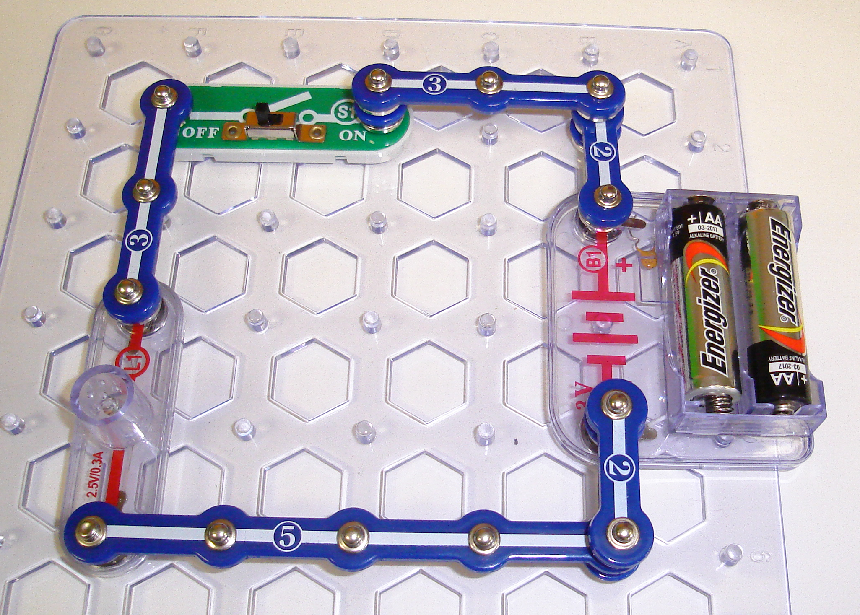

- Draw the proper schematic diagram for the circuit above using proper electrical symbols.

- Close the switch. The light bulb should go on. If the bulb does not go on, ask for help.

- Remove one piece from the circuit.
  - What happens?

  - Explain why that happened.

- Get meter M5 and set to 1A.

- Snap the meter to the circuit board. Attach red wire to (+) end and the black wire to (–) end. This is an AMMETER that measures CURRENT. It should be the only conductor carrying electricity, so use it instead of a blue section of snappy circuit. The red wire should always be closest to the (+) terminal of the battery. Caution: if the meter’s needle moves to the LEFT, then the wires are reversed.

- Complete the following table by removing the proper piece of your circuit and connecting the ammeter in place of that piece. (this is called a SERIES connection) Read the numbers from 0-1 under the A (middle scale)

CURRENT IN A SERIES CIRCUIT
Position of Ammeter | Current reading (amps)
after negative end of battery
after switch
after light bulb
What do you notice about these readings?

Why does that have to be the way it is?

- Remove the ammeter and its wires.

- Rebuild your circuit with the switch closed so the light is on.
Procedure – Part 2 → Voltage in a Series Circuit

- Get meter M5 and set to voltage by moving the switch to the far left (5V). Attach red wire to (+) end and the black wire to (–) end. This is a VOLTMETER that measures VOLTAGE. Your readings will now come from the top of the scale (1-5V).

- The voltmeter is added to the circuit without taking any parts of the circuit out. (this is called a PARALLEL connection). This is done by snapping the leads on top of the positions required.

- Complete the following table by connecting the voltmeter to the two positions indicated by the word ‘across’.

VOLTAGE IN A SERIES CIRCUIT
Position of Voltmeter | Voltage reading (volts)
across the battery
across the first connector |  | add up these voltages here
across the switch |  | add up these voltages here
across the next connector |  | add up these voltages here
across the light bulb |  | add up these voltages here
across the next connector |  | add up these voltages here
Compare the voltage given by the battery to the voltage drops across all parts of the circuit outside the battery.

Why does that have to be the way it is?

Why is there a zero voltage reading across the connectors?

Conclusion
Write a general statement about the current in a series circuit.

Write a general statement about the voltage in a series circuit.
Snappy Circuits
Activity 2
Another Series Circuit

Purpose – More investigation of current and voltage in a series circuit.
Materials – Snappy Circuits Kit
Procedure – Part 1

- Build a circuit like the one in the picture below. All pieces should snap flat. Make sure there are no angled parts.

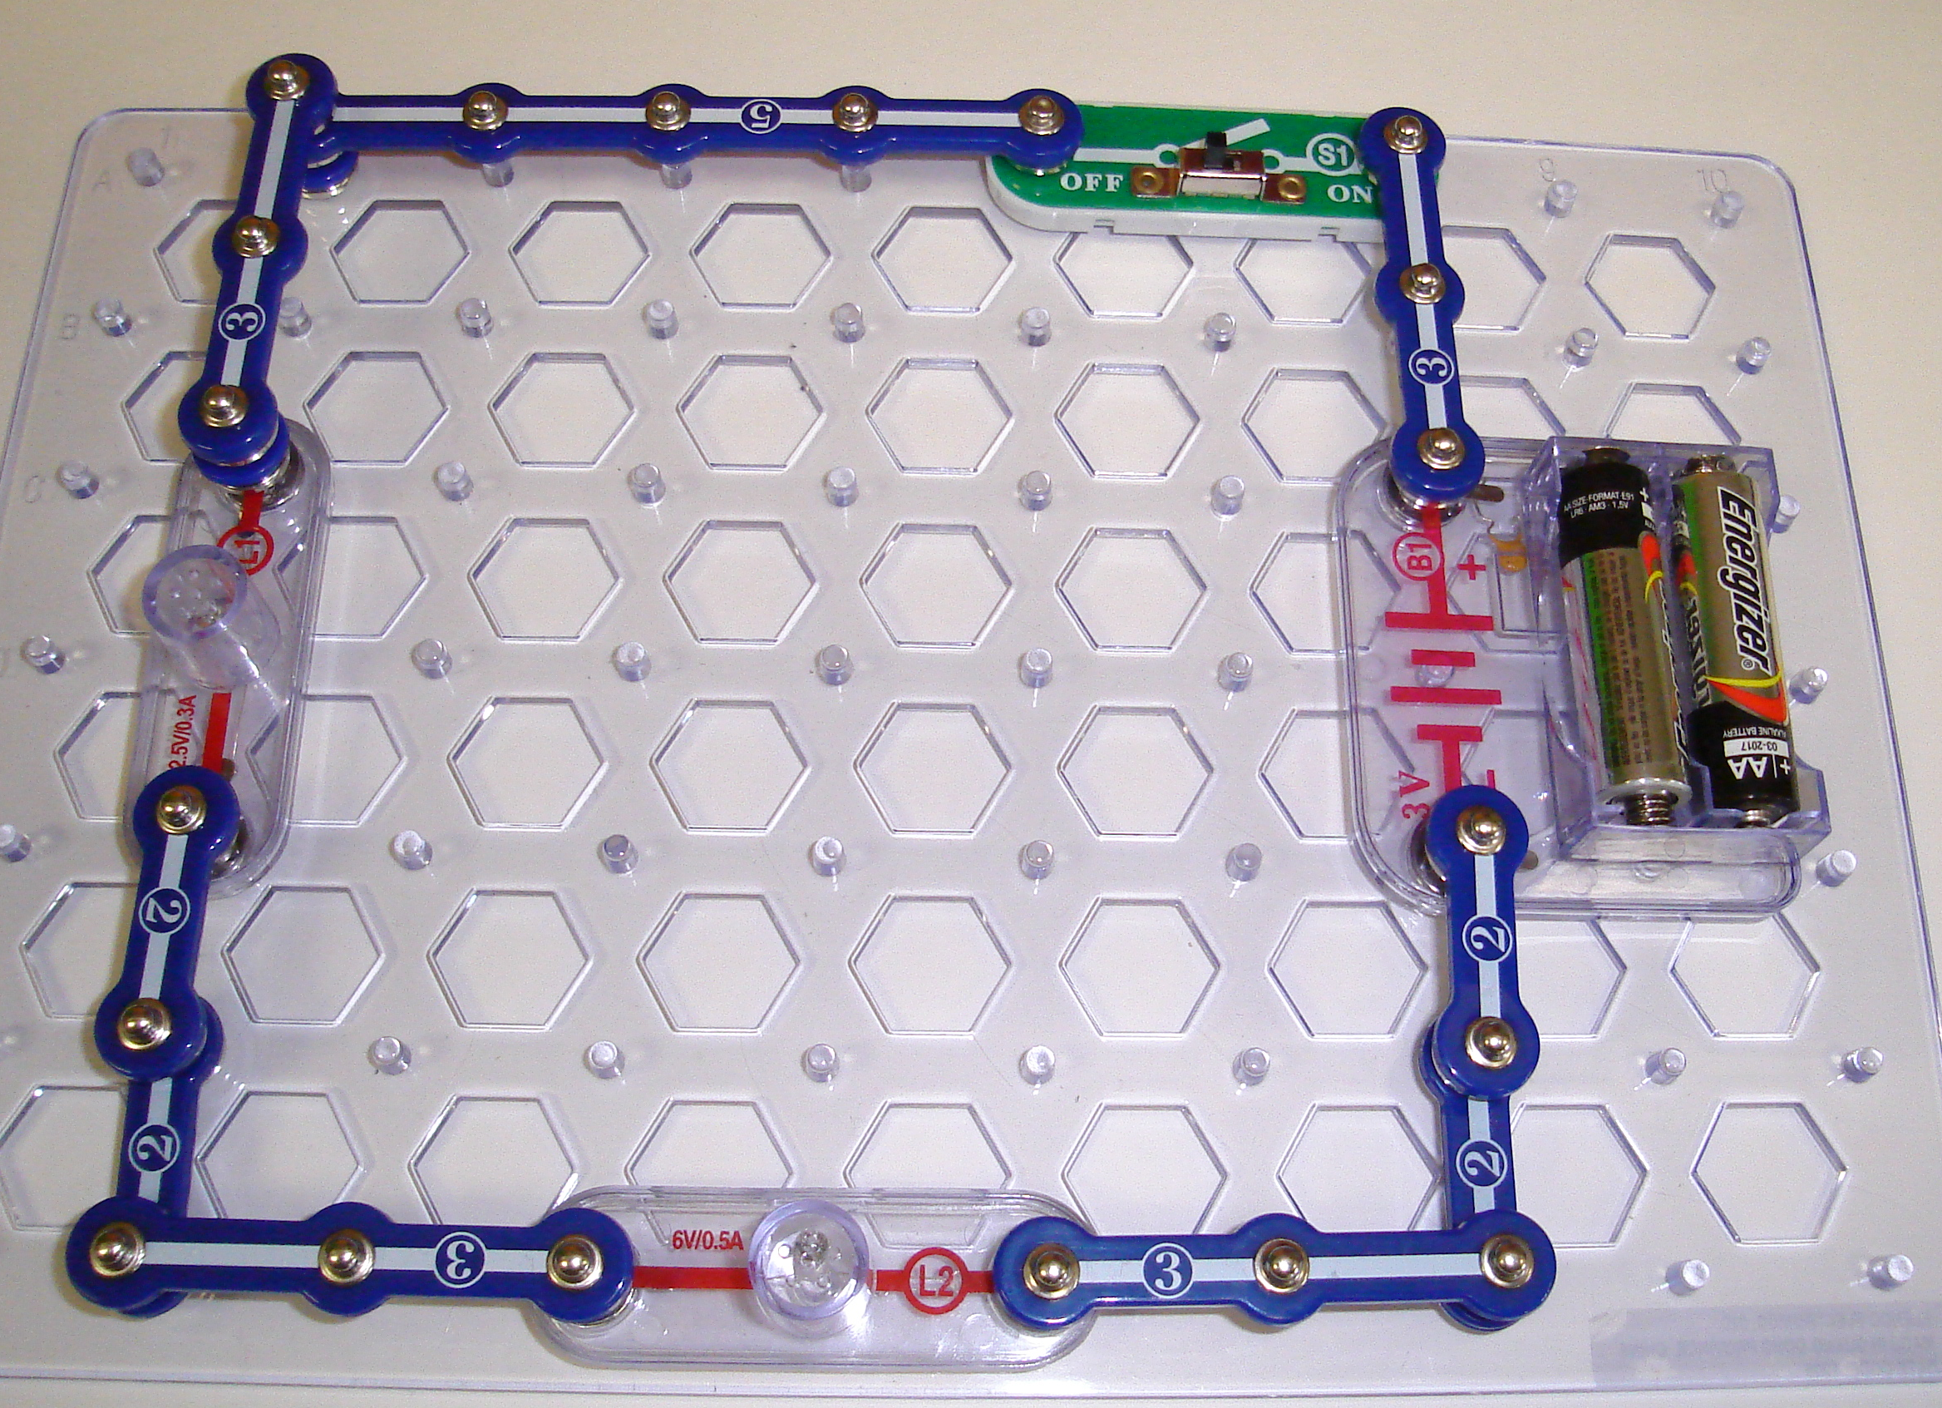

- Draw the proper schematic diagram for the circuit above using proper electrical symbols.

- Close the switch. The light bulb should go on. If the bulb does not go on, ask for help.

- Are the bulbs brighter or dimmer than in Activity 1?
Explain

- Remove one piece from the circuit.
  - What happens?

  - Explain why that happened.

- Get meter M5 and set to 1A.

- Snap the meter to the circuit board. Attach red wire to (+) end and the black wire to (–) end. This is an AMMETER that measures CURRENT. It should be the only conductor carrying electricity, so use it instead of a blue section of snappy circuit. The red wire should always be closest to the (+) terminal of the battery. Caution: if the meter’s needle moves to the LEFT, then the wires are reversed.

- Complete the following table by removing the proper piece of your circuit and connecting the ammeter in place of that piece. (this is called a SERIES connection) Read the numbers from 0-1 under the A (middle scale)

CURRENT IN A SERIES CIRCUIT
Position of Ammeter | Current reading (amps)
after negative end of battery
after switch
after the first light bulb
after the second light bulb
What do you notice about these readings?

Why does that have to be the way it is?

- Remove the ammeter and its wires.
- Rebuild your circuit with the switch closed so the light is on.

Procedure – Part 2 → Voltage in a Series Circuit

- Get meter M5 and set to voltage by moving the switch to the far left (5V). Attach red wire to (+) end and the black wire to (–) end. This is a VOLTMETER that measures VOLTAGE. Your readings will now come from the top of the scale (1-5V).

- The voltmeter is added to the circuit without taking any parts of the circuit out. (this is called a PARALLEL connection). This is done by snapping the leads on top of the positions required.

- Complete the following table by connecting the voltmeter to the two positions indicated by the word ‘across’.

VOLTAGE IN A SERIES CIRCUIT
Position of Voltmeter | Voltage reading (volts)
across the battery
across the first light bulb |  | _{add}
across the second light bulb |  | _{add}
Compare the voltage given by the battery to the voltage drops across all parts of the circuit outside the battery.

Why does that have to be the way it is?

Conclusion
Write a general statement about the current in a series circuit.

Write a general statement about the voltage in a series circuit.
Snappy Circuits
Activity 3
Parallel Circuits

Purpose – to investigate the current and voltage in a parallel circuit.

Materials – Snappy Circuits Kit

- Build a circuit like the one in the picture below. All pieces should snap flat. Make sure there are no angled parts.
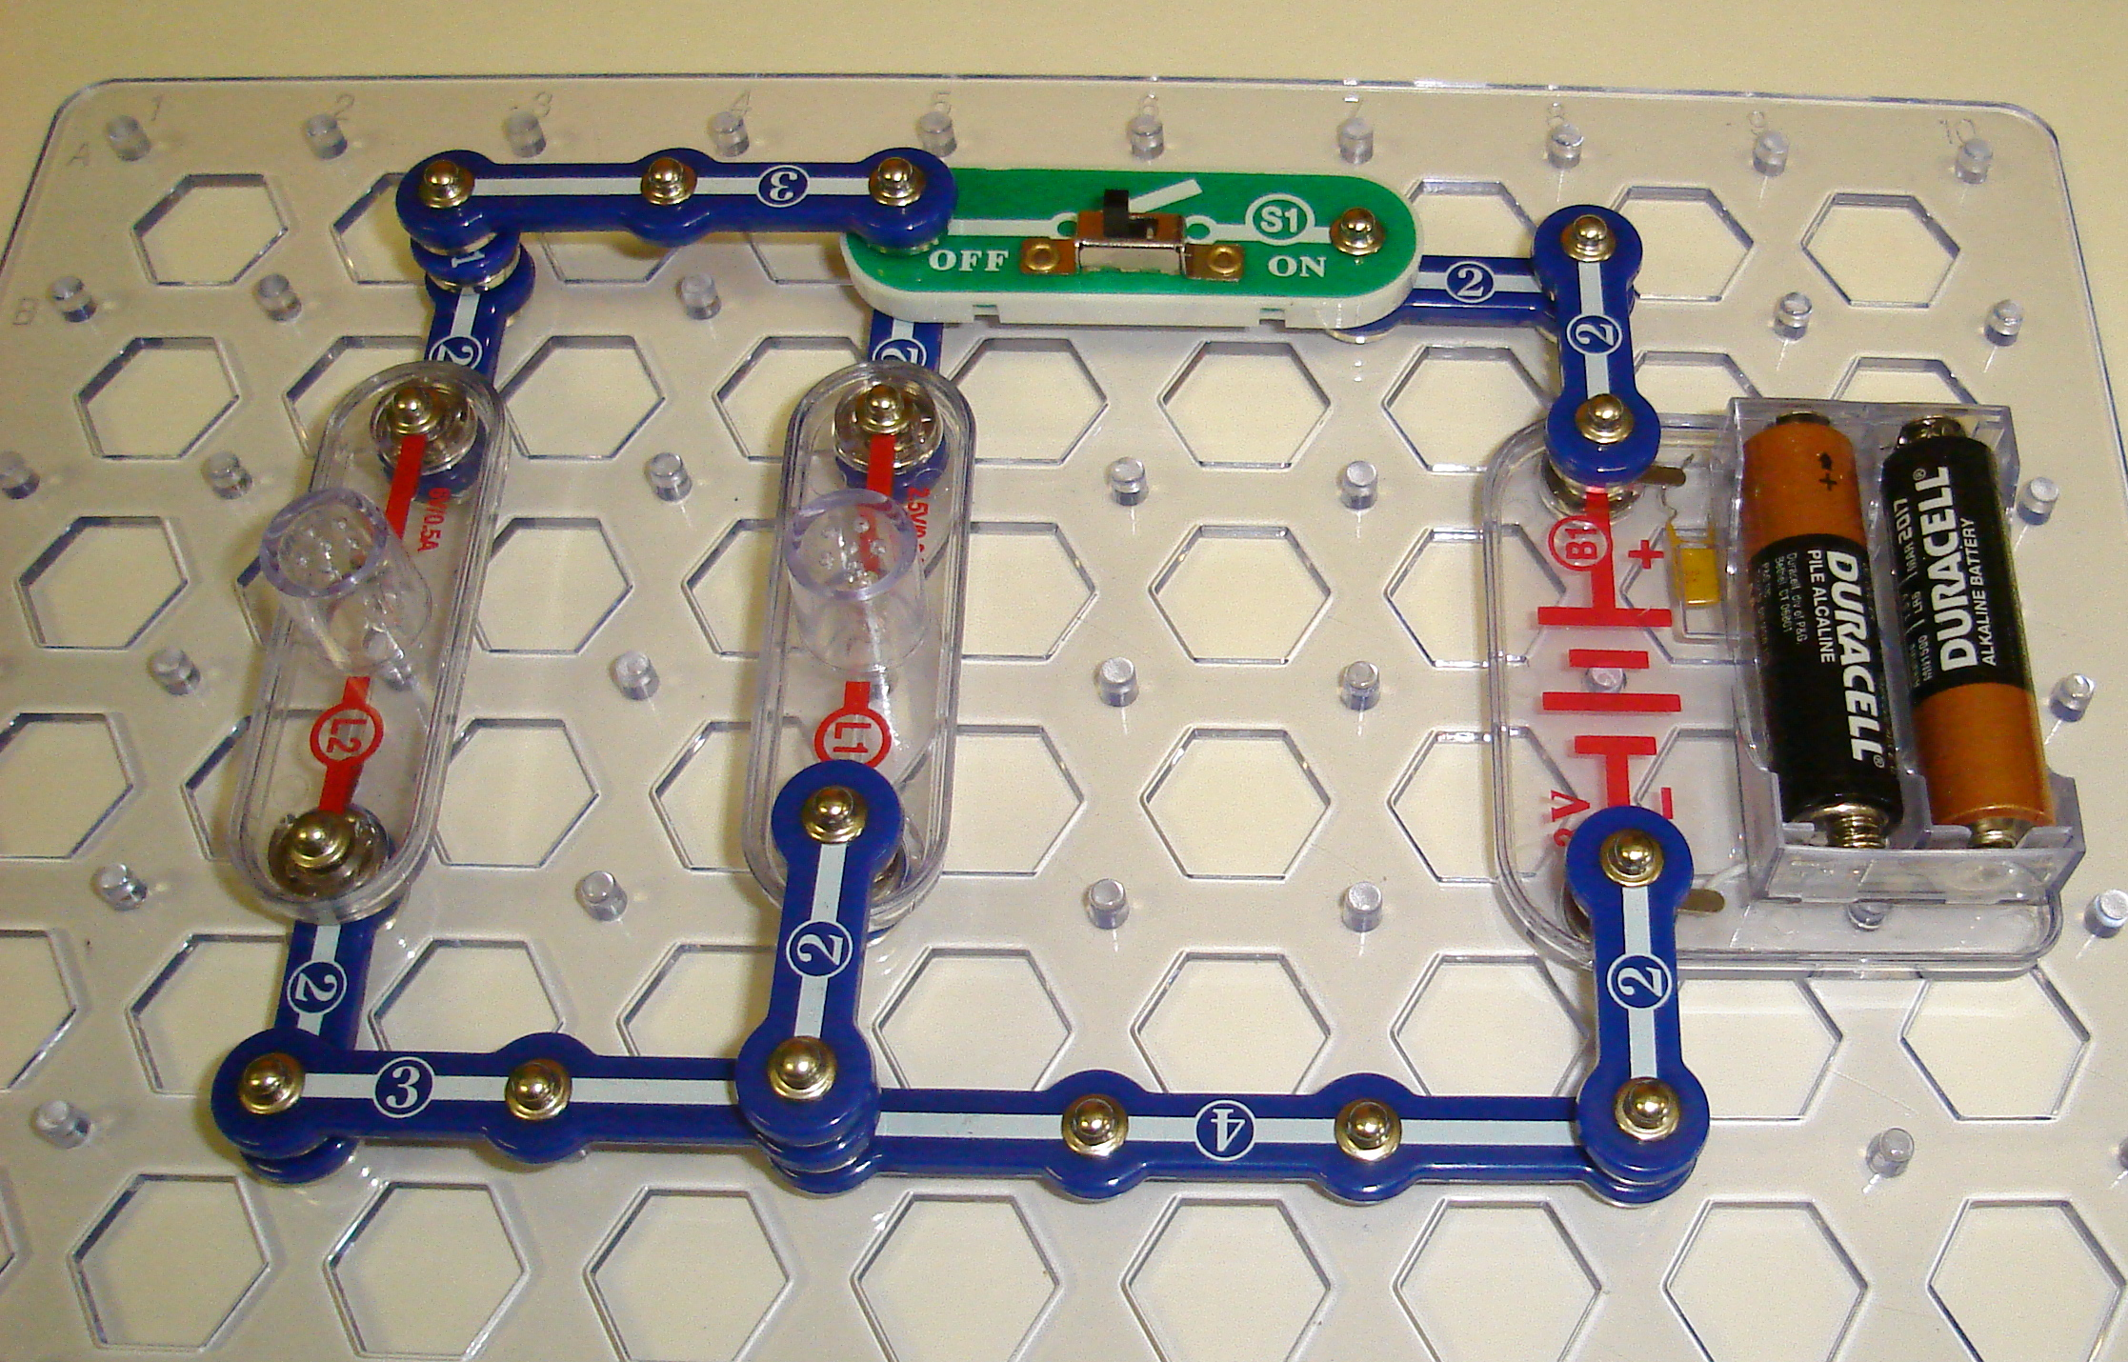

- Draw the proper schematic diagram for the circuit above using proper electrical symbols.

- Close the switch. The light bulbs should go on. If the bulbs do not go on, ask for help.

- Get meter M5 and set to 1A.

- Snap the meter to the circuit board. Attach red wire to (+) end and the black wire to (–) end. Caution: if the meter’s needle moves to the LEFT, then the wires are reversed.

- Complete the following table by removing the proper piece of your circuit and connecting the ammeter in place of that piece. Read the numbers from 0-1 under the A (middle scale)

CURRENT IN A PARALLEL CIRCUIT
Position of Ammeter | Current reading (amps)
after negative end of battery
along the path of the first light bulb |  | _{add}
along the path of the second light bulb |  | _{add}
What do you notice about these two readings compared to the reading after the battery?

Why does that have to be the way it is?

Measure the current just before going back into the battery.

Why does this have to be the way it is?

- Remove the ammeter and its wires.

- Rebuild your circuit with the switch closed so the lights are on.
Procedure – Part 2 → Voltage in a Series Circuit

- Get meter M5 and set to voltage by moving the switch to the far left (5V). Attach red wire to (+) end and the black wire to (–) end. Your readings will now come from the top of the scale (1-5V).

- The voltmeter is added to the circuit without taking any parts of the circuit out. This is done by snapping the leads on top of the positions required.

- Complete the following table by connecting the voltmeter to the two positions indicated by the word ‘across’.

VOLTAGE IN A PARALLEL CIRCUIT
Position of Voltmeter | Voltage reading (volts)
across the battery
across the first light bulb
across the second light bulb
Compare the voltage given by the battery to the voltage drops along each path.

Why does that have to be the way it is?

Conclusion

Write a general statement about the current in a parallel circuit.

Write a general statement about the voltage in a parallel circuit.

Electricity - 12

 | Take up some HW
 | Ohms law – can be done as a full lab (attached) or as a demo or just using the data from the circuit building activity the last two days
Ohm’s Law – the most important formula in electricity. It relates voltage, current and resistance.

V = I R

Does this make sense?
If I decrease R, what has to happen to I to keep V the same?
If I increase R, what has to happen to I to keep V the same?
If V increases and R stays the same, what must happen to I?
HW | Can now finish circuit analysis handout  Ohm’s law worksheet

Power Pack

DC 6V

A
V
Rheostat

Ohm’s Law

DO NOT TURN ON THE POWER SOURCE UNTIL CHECKED.

- Measure the resistance of an outside resistor and the middle resistor.

- Enter that value in the observations below and reverse.

- Build the circuit according to the diagram on the board. Use one of the resistors on the edge of the circuit board as the resistor.

- By adjusting the Rheostat, fill in the chart below.

Resistor’s measured Resistance

Target Voltage | Actual Measured Voltage | Current in milliamps (mA) | Current in Amps  (mA/1000) | V  I  Column 2 divided by column 4

1 V

2 V
3 V
4 V

5 V

Average V = This is the calculated resistance
I according to Ohm’s Law.
Remember:
R = V
I
DO NOT TURN ON THE POWER SOURCE UNTIL CHECKED.

- Build the circuit according to the diagram on the board. Use a resistor with a different resistance. This should only require unhooking the two leads on the old resistor and attaching the two leads to the new resistor.

- By adjusting the Rheostat, fill in the chart below.

Resistor’s measured Resistance

Target Voltage | Actual Measured Voltage | Current in milliamps (mA) | Current in Amps  (mA/1000) | V  I  Column 2 divided by column 4

1 V

2 V
3 V
4 V

5 V

Average V = This is the calculated resistance
I according to Ohm’s Law.

Remember:
R = V
I

Ohm’s Law Worksheet

1. Solve the following:

 | Current (A) | Resistance (Ω) | Potential Difference (V)
a | 2 | 3 | ?
b | 5 | ? | 10
c | ? | 12 | 24
d | 6.5 | 4.2 | ?
e | 3.3 | ? | 24
f | ? | 15 | 60
g | 5.5 | ? | 32
h | ? | 0.6 | 3
i | 0.05 | 0.2 | ?
j | 100 | ? | 230

2. What voltage is required to force a current flow of 3A if the resistance is 50Ω?

3. An electric iron has a resistance of 150 Ω. How much current will flow when the voltage is 120V?

4. An electric tea kettle operates on 120V. What resistance does it have if 3.3 A of current flow?

5. What resistance does a toaster have if the voltage is 12oV and the current flow is 2.3A?

6. The reading on a voltmeter is 9.2V and the ammeter reading is 0.5A. What is the resistance?

7. The electric pressure applied is 67.5 V and the resistance of the circuit is 1500 Ω, calculate the
current.

8. Determine the resistance of the lamp drawing 0.25A at 220V.

9. An electric soldering iron is connected to 120V and draws a current of 2.75A. Calculate resistance.

10. What happens to the current in a closed circuit if the voltage is increased and the resistance remains
constant?

11. What happens to the current in a closed circuit if the resistance is increased and the voltage remains constant?

Electricity - Day 13

Time | 120W and 40W bulbs, generator, sample meters
10 | Take up some HW
30 | Notes circuits review, power, home
HW | R+MN 12.2 D28 pg 491 1 pg 492  1,2,3 pg 493 1-16 pg 498
HW | Meter reading ass’t

Circuits Review

Series
- one path for e-
- current – same at any point
- potential difference – total voltage drops across all resistors must be equal to the
voltage increase at source
-resistance – R_{T} = R₁ + R₂ + R₃…

Parallel
- more than one path for e-
- current – the currents along all paths must add up to the current coming out of the
source
- potential difference – the voltage drop across each parallel path is the same
- resistance - 1 = 1 + 1 + 1 resistance drops with more

R_{T} R₁ R₂ R₃ resistors

Ohm’s Law V = IR

Electrical Power

What is power? Who plays hockey? Who is a more powerful skater, them or me? If we had a race who would win? If we had the same mass, who would win? What if we had the same mass and they won – who put out more energy? Both same. Who has higher power? They do because they exerted that energy in a shorter time.

Power is the rate of using energy P = E energy in Joule → Watt
t time in sec

demo 120W vs 40W bulb

Electricity at Home

Have one student crank the generator – they will do this as long as possible. Keep going with the lesson while they do this. Emphasize the amount of energy used as electrical energy. How much energy do we use? Lots → pollution etc.

Are homes wired in parallel or series? – parallel – one light out, others stay on.

Homes are wired in parallel – otherwise when you turned an appliance off all the appliances on that circuit would not work.

Think!

Since homes are wired in parallel as you add more appliances to an outlet (power bar plugged into a power bar) the resistance DECREASES! The voltage at the outlet is the same – 120V. What happens to current? V = IR → I = V stays same
R decreases
Current gets very big – hot – fires!

Every house has an electrical panel. This panel has fuses (old) or circuit breakers. The fuse has a thin wire in it that melts when it gets hot. If it melts it breaks the circuit (it then needs to be replaced). A circuit breaker is a switch that flips open when it gets hot – reusable.

We buy electrical energy (not power). What is the unit of electrical energy we buy?

kW*h = 1000 W*h = 1000 J * 3600s = 3 600 000 J = 3.6MJ
s

How does the electrical company know how much energy we’ve used?

The electrical meters on our house count the energy used.

Go through handout – energy consumption – reading a hydro meter

Percent Efficiency

If you got 7 out of 10 on a quiz, what is your percent efficiency.

Percent efficiency = Energy out * 100%

Energy in

Which is more efficient? Calculate the efficiencies
a) an incandescent bulb that uses 125W of electricity to produce 7 W of light.
b) a compact fluorescent bulb that uses 27W of electricity to produce 7W of light.

Home Electricity Assignment

10
Name:__________________

Over the next week take seven readings from your electricity meter.
Calculate the electricity used and the total cost for the week.
Date | Reading | Change from previous reading | Cost/kWh | Cost
 |  |  | $ 0.11
 |  |  | $ 0.11
 |  |  | $ 0.11
 |  |  | $ 0.11
 |  |  | $ 0.11
 |  |  | $ 0.11
Total cost for one week

Home Electricity Assignment

10
Name:__________________

Over the next week take seven readings from your electricity meter.
Calculate the electricity used and the total cost for the week.
Date | Reading | Change from previous reading | Cost/kWh | Cost
 |  |  | $ 0.11
 |  |  | $ 0.11
 |  |  | $ 0.11
 |  |  | $ 0.11
 |  |  | $ 0.11
 |  |  | $ 0.11
Total cost for one week

Electricity - Day 14

Time | Sources of electricity kit, wet cell, potato clock
10 | Take up HW
HW | R+MN 432 – 436  #1-5 pg 436  R+MN 12.1  #1-5 pg 479  #1-5 pg 483  D26 pg 486 #1,3  #1-12 pg 489  pg 500#1-21

Electricity - Day 15

Time

Energy conservation ass’t due tomorrow

Electricity - Day 16,17,18,19,20

Time
16 | Energy resource project
17 | Video Inconvenient Truth  Who Killed the Electric Car
18 | Review for test, work on energy ass’t
19 | Review for test, work on energy ass’t
20 | Test - Electricity

Electricity Review

This review will be handed in the day of the test and count as a question on the test.

1. Summarize you notes. Summarize that summary. Continue until you get down to
one page.

2. Make sure all your homework from the unit is complete.

3. State the charge on the following – proton, neutron, electron, nucleus, atom with
equal number of e- and p+, atom with more e- than p+.

4a). An object is charged by conduction with a negative rod. What charge is on the
object?
b) An object is charged by induction with a negative rod. What charge is on the
object?

5. What is the difference between a cell and a battery?

6. To make a toaster would you use high or low resistance wires in the cooking slots?
Explain.

7. What is the total resistance of the following resistors:
a) 6 Ω,2 Ω,5 Ω in series ans. 13 Ω
b) 6 Ω,2 Ω,5 Ω in parallel ans. 1.15Ω

8. What is the potential drop if the current through a 50 Ω resistor is 2.5A?
ans. 125V

9. Find the current if the potential across a 20 Ω resistor is 10V. ans. 0.5A

10. Find the total resistance for each circuit.

a) 3Ω b) c) 5Ω

7Ω 3Ω 7Ω 3Ω
7Ω

ans. 10 Ω ans. 2.1 Ω ans. 7.1 Ω

11. Given V_{ab} = 15V Find I_{b} a b c
R₁ = 7 Ω V_{bc} 40V R₁ R₂
I_{c} = 1.5A R_{T}
R₂

Ans. I_{b} = 2.14A V_{bc} = 25V R_{T} = 18.7Ω R₂ = 11.7Ω

12. Chapter 10 review – pg 428 # 1-21
Chapter 11 review – pg 470 # 1-17
Chapter 12 review – pg 500 # 1-19

